- Circle Theorems
- Angles at the centre and circumference
The angle at the centre is double the angle at the circumference
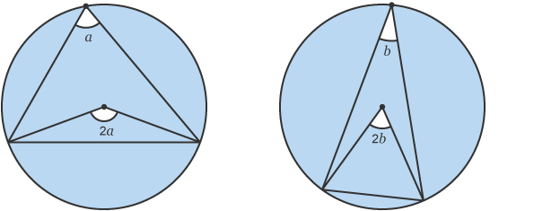

- Angles in the same segment
Angles in the same segment are equal.

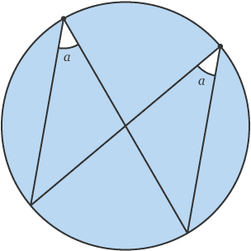

- Cyclic quadrilateral
A cyclic quadrilateral is a quadrilateral drawn inside a circle. Every vertex of the quadrilateral must touch the circumference of the circle.
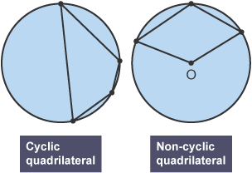
The second shape is not a cyclic quadrilateral. One vertex does not touch the circumference.
The opposite angles in a cyclic quadrilateral add up to 180°.
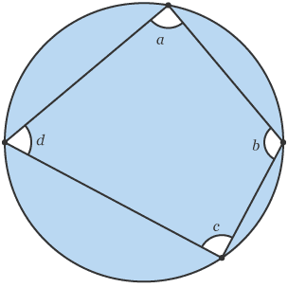

- Angles in a semicircle
The angle at the circumference in a semicircle is a right angle.
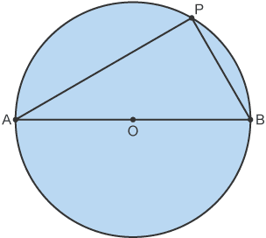

Angle APB = 90°
- The angle between a tangent and a radius is 90°.

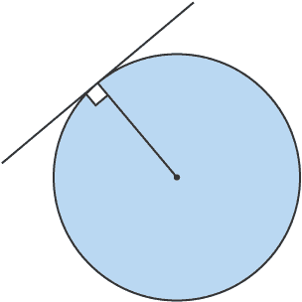

- Tangents which meet at the same point are equal in length.
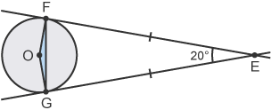
- Chords
The perpendicular from the centre of a circle to a chord bisects the chord.
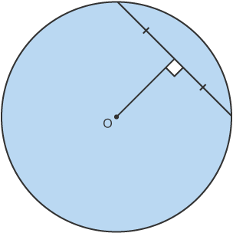

- The alternate segment theorem
The angle between a tangent and a chord is equal to the angle in the alternate segment.
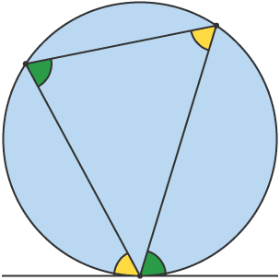

- Angle Theorems

- The exterior angle is equal to the sum of the two opposite interior angles. This is true for any triangle.
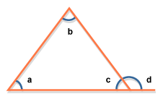
d = a + b

- Quadrilaterals

The angles in a quadrilateral add up to 360º. There are other facts that you will need to know about special types of quadrilaterals. These are shown below:

Square
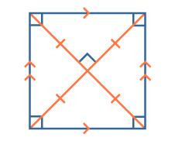

A square is a regular quadrilateral. All of its angles are equal (90°). All of its sides are of equal length. Opposite sides are parallel. The diagonals bisect each other at 90°. The diagonals are equal in length. It has 4 lines of symmetry. Order of rotational symmetry: 4.

Rhombus
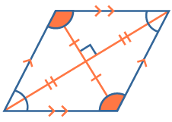

Diagonally opposite angles are equal. All of its sides are of equal length. Opposite sides are parallel. Diagonals bisect each other at 90°. It has 2 lines of symmetry. Order of rotational symmetry: 2.

Rectangle
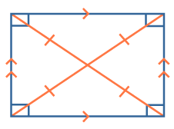

All angles are equal (90°). Opposite sides are of equal length. Opposite sides are parallel. The diagonals bisect each other. The diagonals are equal in length. It has 2 lines of symmetry. Order of rotational symmetry: 2.

Parallelogram
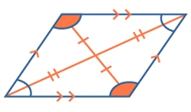

Diagonally opposite angles are equal. Opposite sides are of equal length. Opposite sides are parallel. The diagonals bisect each other. It has no lines of symmetry. Order of rotational symmetry: 2.

Trapezium
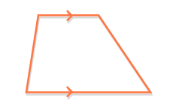

One pair of opposite sides is parallel. It has no lines of symmetry. It has no rotational symmetry.

Kite
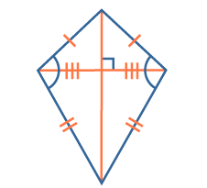

Two pairs of sides are of equal length. One pair of diagonally opposite angles is equal. Only one diagonal is bisected by the other. The diagonals cross at 90°. It has 1 line of symmetry. It has no rotational symmetry.
- Angle properties of polygons

The formula for calculating the sum of the interior angles of a regular polygon is: (n - 2) × 180° where n is the number of sides of the polygon.
- Interior angle of a regular polygon = sum of interior angles ÷ number of sides

- Exterior angle

Exterior angle of a regular hexagon is
- Vertically opposite angle

When two lines intersect, the opposite (X) angles are equal:
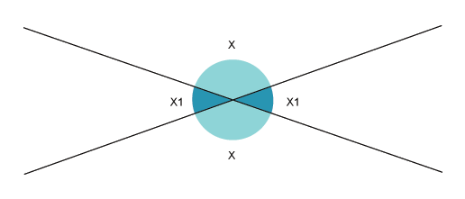
- Alternate (Z) angle

On parallel lines, alternate (Z) angles are equal:
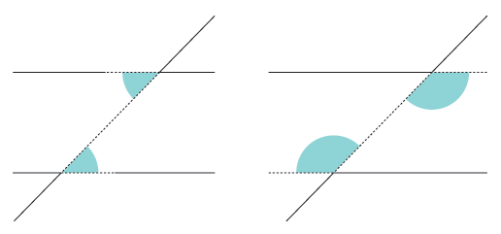
- Corresponding (F) angle

On parallel lines, corresponding (F) angles are equal:

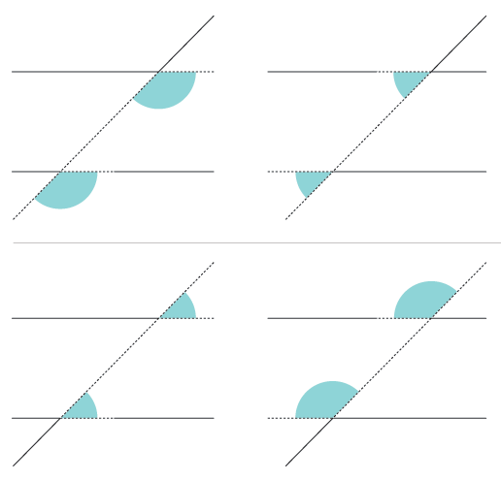
- Interior (C) angle

On parallel lines, co-interior (C) angles add up to 180°:

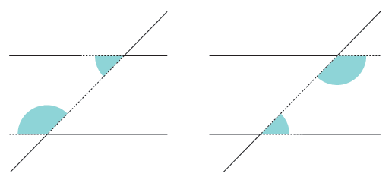

- Table for Sin, Cos & tan

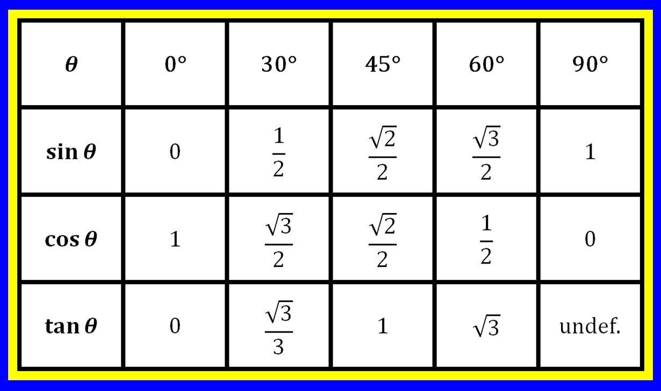

- Graph for Sin, Cos & tan
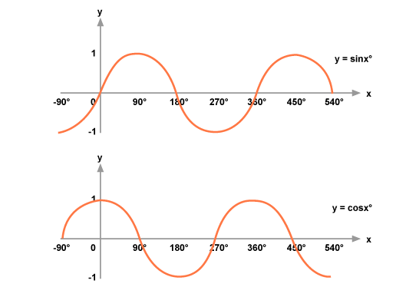
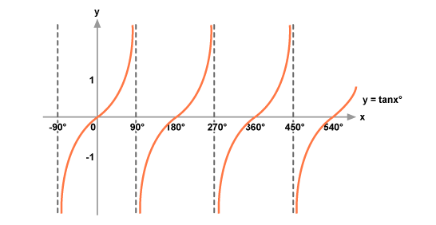
- Sine Rule, Cosine Rule & Area of Triangle
- Sine Rule
We can use the sine rule to find the size of an angle or length of a side.
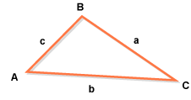
The sine rule is:
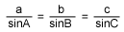
OR
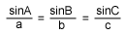
- The cosine rule
We can use the cosine formula to find the length of a side or size of an angle.
For a triangle with sides a,b and c and angles A, B and C the cosine rule can be written as:
- a² = b² + c² - 2bc cos A

OR

- b² = a² + c² - 2ac cos B

OR

- c² = a² + b² - 2ab cos C

These formulae can be rearranged to give:
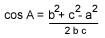
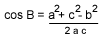
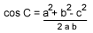
- The area of a triangle

Area of triangle ABC = ¹/₂ab sin C
or, ¹/₂ac sin B
or, ¹/₂bc sin A

- Area

- Square --------> Area = Length²
- Rectangle --------> Area = Length * Width
- Right-angled Triangle --------> Area = ½ x Base * Height
- Other Triangle --------> Area = ½ x Base * Perpendicular Height
- Circle --------> Area = π * r²
- Trapezium --------> Area = ½ ( a + b ) * h
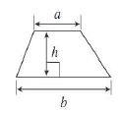
- Parallelogram --------> Area = base * height

- Surface Area

- Curved Surface Area of a Cylinder --------> Area = 2 * π * r * h
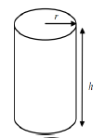
- Surface area of a Sphere --------> Area = 4 * π * r²
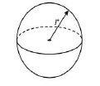
- Total Surface area of a Cone --------> π * r * l + π * r²
- Curved Surface area of a Cone --------> Area = π * r * l
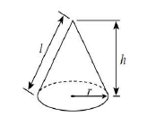
- Frustum(Truncated Cone) --------> Area = 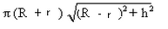
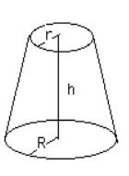
- Volume

- Cube --------> Volume = Length³
- Cuboid --------> Volume = Length * Width * Height
- Prism --------> Volume = Area of Cross-section * Length
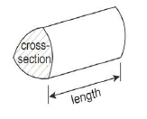
- Cylinder --------> Volume = π * r² * h
- Sphere --------> Volume = 4/3 * π * r³

- Cone --------> Volume = 1/3 * π * r² * h
- Frustum(Truncated Cone) --------> Volume = πh/3 ( R² + R*r+ r²)

- Circumference or Perimeter

- Circle --------> Circumference = 2 * π * r OR π * D
- Rectangle --------> Perimeter = 2 ( Length + Width )
- CAST Diagram

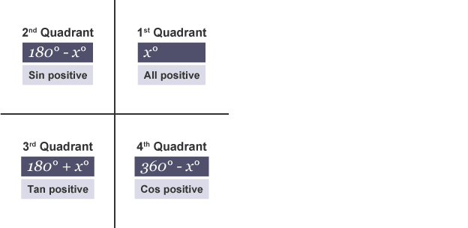

- Trigonometric Identities
These are:
cos²x = 1 - sin²x
sin²x = 1 - cos²x
And:
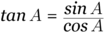

- Differentiation
The rule for differentiation is
or, using the Leibniz notation
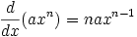
- Equation of a circle
The equation of a circle with radius r and centre (0, 0) is given by the formula

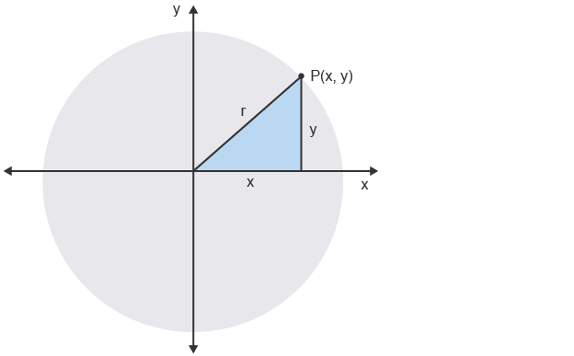
- Transformation of Graphs

- Translations parallel to the y-axis
Represents a translation through the vector .
If, then. Here we are adding to the whole function.
The addition of the value represents a vertical translation in the graph. If is positive, the graph translates upwards. If is negative, the graph translates downwards.

Example 1
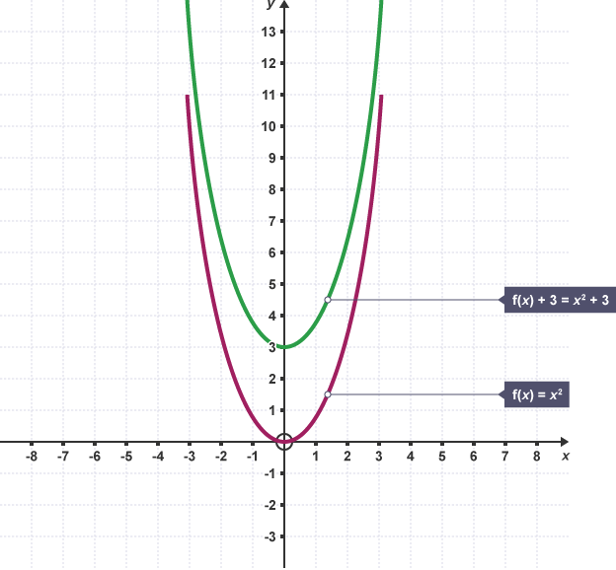

Example 2
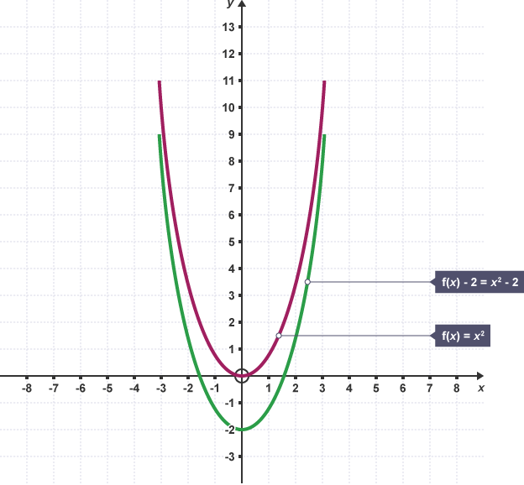
- Translations parallel to the x-axis
Represents a translation through the vector 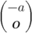.

If then .
Here we add to , not to the whole function. This time we will get a horizontal translation. If is positive then the graph will translate to the left. If the value of is negative, then the graph will translate to the right.

Example 1
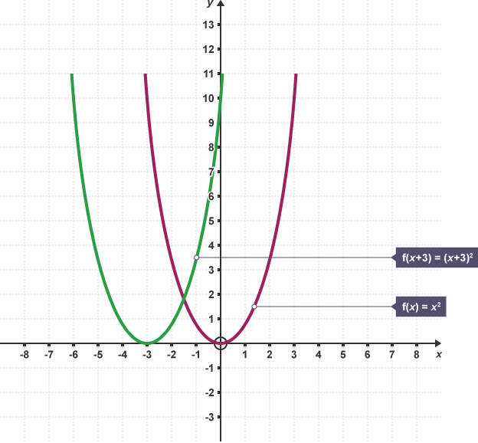

Example 2
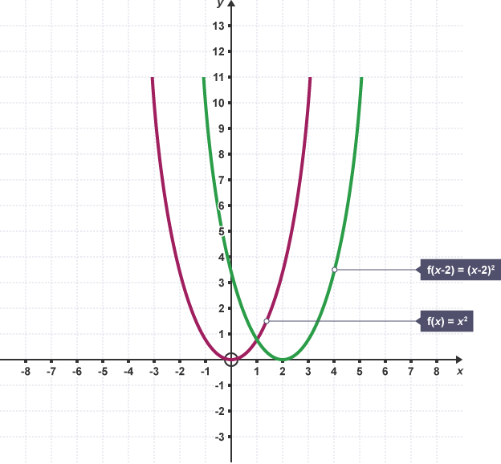
- Reflections in the x-axis
If , then .
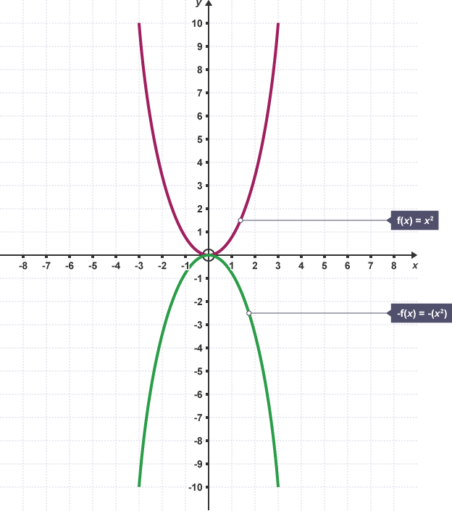
- Reflections in the y-axis
If , then .

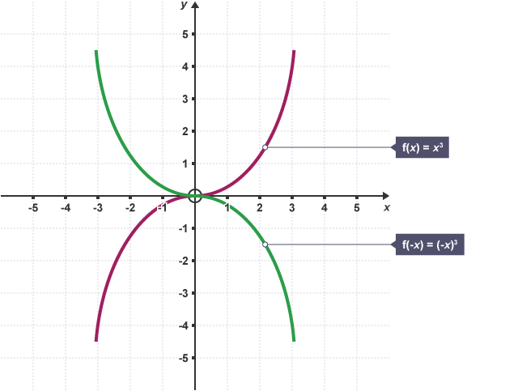

Summary
y = f(x) + C | - C > 0 moves it up  - C < 0 moves it down
y = f(x + C) | - C > 0 moves it left  - C < 0 moves it right
y = Cf(x) | - C > 1 stretches it in the y-direction  - 0 < C < 1 compresses it
y = f(Cx) | - C > 1 compresses it in the x-direction  - 0 < C < 1 stretches it
y = −f(x) | - Reflects it about x-axis
y = f(−x) | - Reflects it about y-axis

