GCSE Similarity

Test Your Understanding
[Nov 2008 4H Q22] $ABCD$ and $PQRS$ are mathematically similar.
- Find the length of $PQ$.
- Find the length of $AD$.
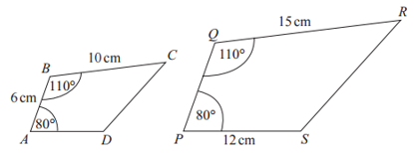
Test Your Understanding
The diagram shows a square inside a triangle. DEF is a straight line. What is length EF?
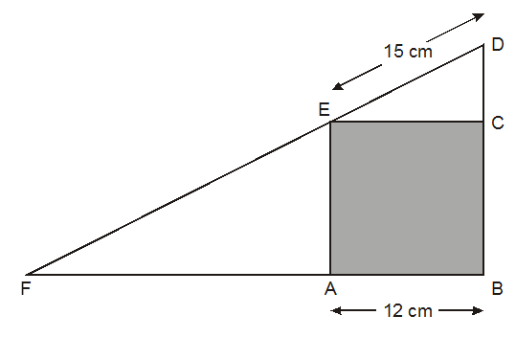
Exercise 1
Question 1: The two triangles are mathematically similar. Find $x$ and $y$.
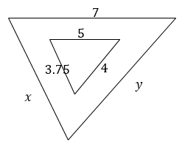
Question 2: Find:
- $BC$
- $AC$
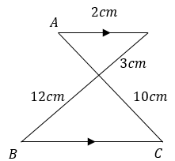

Question 3: Determine $x$.
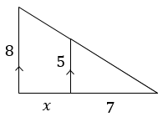
Question 4: Determine $x$.
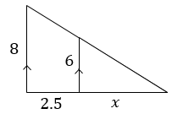
Question 5: [June 2014 2H Q17] Quadrilaterals $ABCD$ and $LMNP$ are mathematically similar.
(a) Determine the length of $LP$.
(b) Determine the length of $BC$.
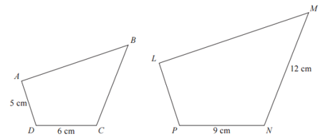
Question 6: A swimming pool is filled with water. Find $x$.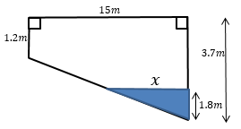
Question 7: [November 2011 4H Q17]
Triangle $ABC$ is similar to triangle $ADE$. Work out the length of $DE$.
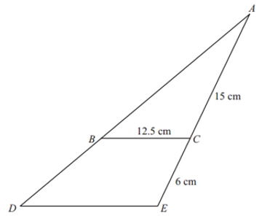
Question 8: [June 2014 1H Q20] Steve has a photo and a rectangular piece of card.
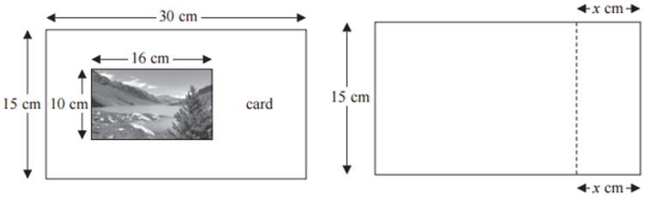
Steve cuts the card along the dotted line shown in the second diagram.
Steve throws away the piece of card that is 15cm by $x$ cm. The piece of card he has left is mathematically similar to the photo. Work out the value of $x$.
Question 9: In the following diagram $∠ABC=∠BCD$ and $∠ADB=∠BDC$. Determine $x$.
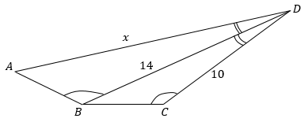
Question 10: [IMC 2006 Q23] In the figure, $PQ=2\frac{1}{3}$, $PS=6\frac{6}{7}$ and $∠QPR=∠RPS$. How long is $PR$?
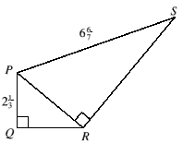
Question ₁: [IMO] A square is inscribed in a 3-4-5 right-angled triangle as shown. What is the side-length of the square?
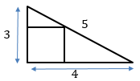

Question ₂: [STMC Regional 2009/10 Q10] $ABDE$ is a square with centre $H$. The base of the square DE is extended so that it meets the straight line CF which passes through H.
If BC = 3 cm and CD = 4 cm find the area of the triangle CDF.
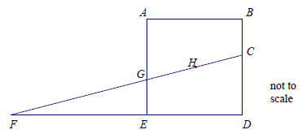
Question ₃: [Source: IMO] Let $a$ and $b$ be the lengths of the two shorter sides of a right-angled triangle, and let $h$ be the distance from the right angle to the hypotenuse. Prove $\frac{1}{a^{2}}+\frac{1}{b^{2}}=\frac{1}{h^{2}}$
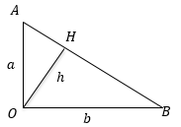
Question ₄: [Source: IMC] The diagram shows a square, a diagonal and a line joining a vertex to the midpoint of a side. What is the ratio of area $P$ to area $Q$?
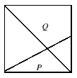

Exercise 2 – Scale Factor of Surface Area and Volume
Question 1: Shapes $A$ and $B$ are mathematically similar. Determine the missing values.
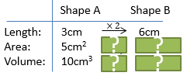
Question 2:
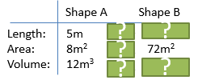
Question 3: [Edexcel 2003] Cylinder A and cylinder B are mathematically similar. The length of cylinder A is 4 cm and the length of cylinder B is 6 cm.
The volume of cylinder A is 80cm³.
Calculate the volume of cylinder B.
Question 4: [Edexcel Nov 2014] $ABCD$ and $AEFG$ are mathematically similar trapeziums.
Trapezium $AEFG$ has an area of $36cm^{2}$. Work out the area of the shaded region.
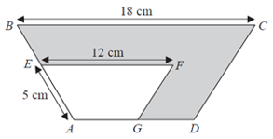
Question 5: [2007] Two cones, P and Q, are mathematically similar. The total surface area of cone P is 24cm².
The total surface area of cone Q is 96cm².
The height of cone P is 4 cm.
(a) Work out the height of cone Q.
(b) The volume of cone P is 12 cm³. Work out the volume of cone Q.
Question 6: [Nov 2013 1H Q16] A company makes monsters. The company makes small monsters with a height of 20cm. A small monster has a surface area of 300cm². The company also makes large monsters with a height of 120cm.
A small monster and a large monster are mathematically similar. Work out the surface area of a large monster.
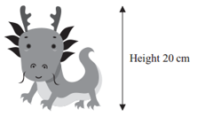
Question 7: [June 2013 1H Q22] $P$ and $Q$ are two triangular prisms that are mathematically similar.
The area of the cross section of $P$ is 10cm². The length of $P$ is 15cm. Work out the volume of prism $Q$.
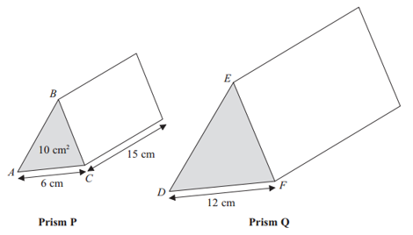
Question 8: [Nov 2012 Q25] The diagram shows two similar solids, $A$ and $B$. Solid $A$ has a volume of 80cm³.
(a) Work out the volume of solid $B$.
(b) If solid $B$ has a total surface area of 160cm², work out the total surface area of $A$.
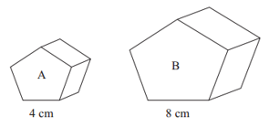

Question 9: [June 2010 Q23] $A$ and $B$ are two solid shapes which are mathematically similar. The shapes are made from the same material.
The surface area of $A$ is 50cm², and of $B$ is 18cm². The mass of $A$ is 500 grams.
Calculate the mass of $B$.
Note that given a fixed density, mass scales in the same way as volume.
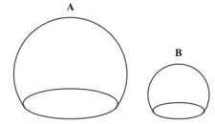
Question : The surface area of shapes A and B are $x$ and $y$ respectively. Given that the length of shape B is $z$, write an expression (in terms of $x$, $y$ and $z$) for the length of shape A.

Exercise 3 – Converting Metric Units of Area and Volume
Convert:
- 42 cm² to mm²
- 2 m² to mm²
- 3 m³ to cm³
- 13 cm³ to mm³
- 5.1 cm² to mm²
- 2 km³ to m³
- 4.25 cm³ to mm³
- 10.01 km² to mm²

